**Zumbatomic Information Instructor: Danielle CastroPoland**

With Zumbatomic, now children can participate in their own special Zumba® class, designed and modified to suit the specific needs of children.  
**Mission Statement**: Mission is to provide an outstanding intensive zumbatomic class for children to not only be physically active, but to learn functional, social and confidence building skills in a safe, positive environment.

**Vision Statement:** Children participate in various skill building activities through movement while learning about different cultures, and why it is important to be active.

**Core Objectives:** The first objective is FUN. The second Children are encouraged to be creative and work together as they make their way to a healthy life. And most importantly, the children are having lots of fun.

**Dress Code:**

Girls: Pants or shorts and tennis shoes

Boys: Pants or shorts and tennis shoes

**Tuition $99.50**

**AC International Presents Zumbatomic**

**Danielle Castropoland**

**ACInternational.Zumbatomic@gmail.com**

**703-517-0721**

**ACI Zumbatomic** “Some things have to be believed to be seen.” - -Ralph Hodgson

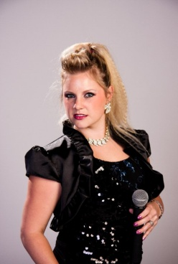

“Open your arms as wide as you can to receive all the miracles with your name on them.”

-Sarah Ban Breathnach

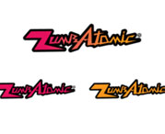

Boys and Girls ages Preschool-and up

Starting September